**Diana Savchuk**

**Assessment Portfolio**

**SQL: Introduction — DH3J 34**

**SCQF level 7**

**Part 2**

**Assessment Part 2**

**Assessment tasks**

The following SQL Statements should be completed in APEX.  
A screenshot should be taken of each completed statement and the Result. All the screenshots should be put into a Word document with an appropriate title (Task 1 Answer, Task 2 Answer etc....) and submitted to the Assessment Dropbox. Please note that all the tasks should be completed before submitting the Word  
document. There is a checklist at the bottom of this document to track your progress.

**Task 1**  
Create a query that uses a natural join to join the departments table and the locations table. Restrict the output to only department IDs of 20 and 50. Display the department id, department name, location id, and city.

**Answer 1:**

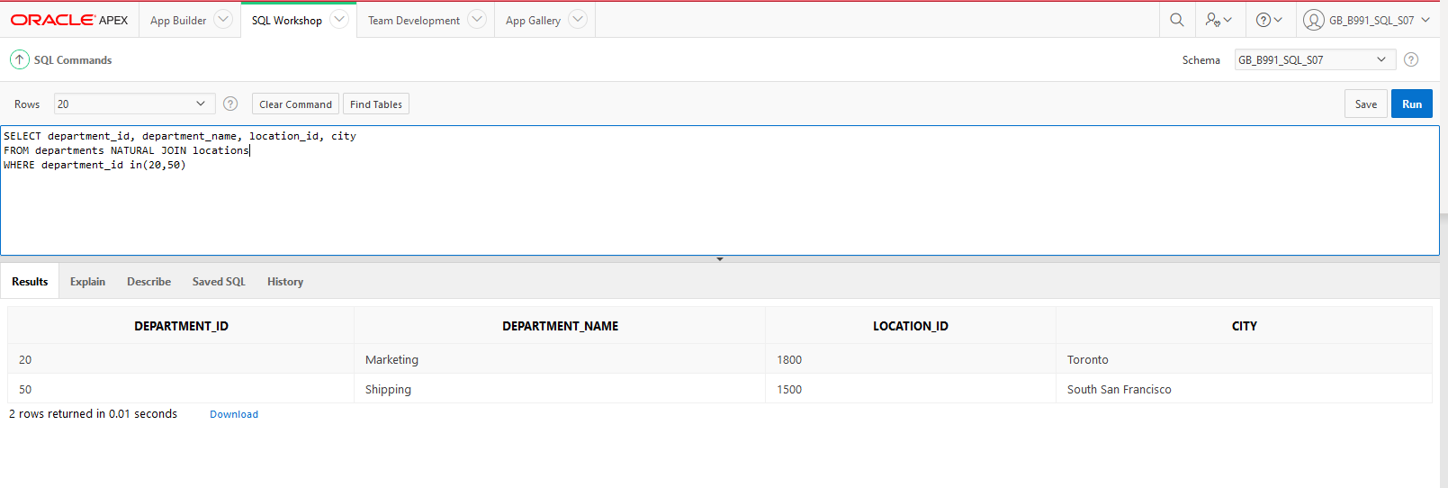

**Task 2**  
Display the city, department name, location ID, and department ID for departments 10, 20, and 30 for the city of Seattle.

**Answer 2:**

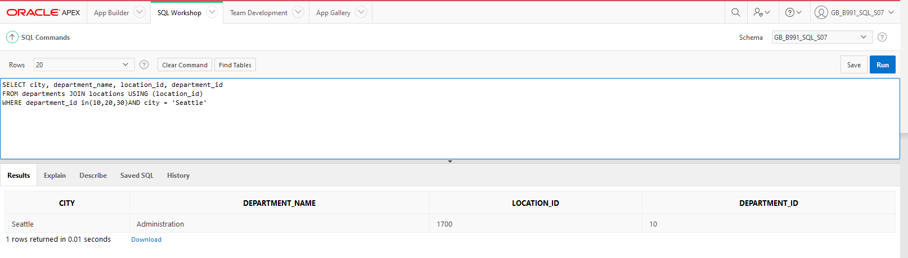

**Task 3**  
Display job title, employee first name, last name, and email for all employees who are stock clerks.

**Answer 3:**

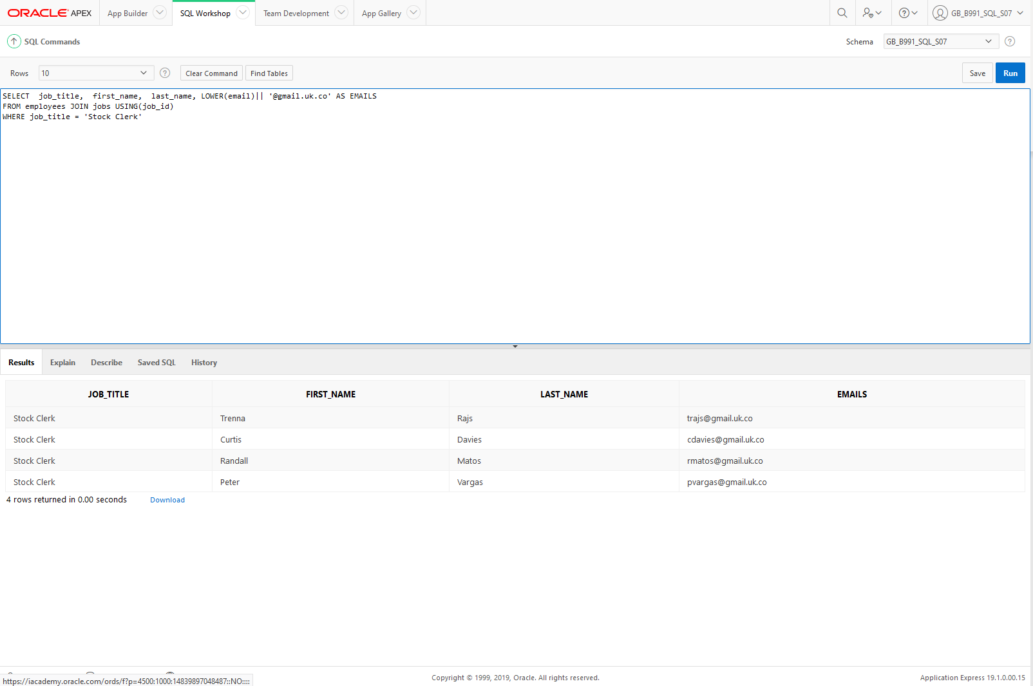

**Task 4**  
Write a statement that ­­­displays the employee ID, first name, last name, manager ID, manager first name, and manager last name for every employee in the employees table. Hint: this is a self-join.

**Answer 4:**

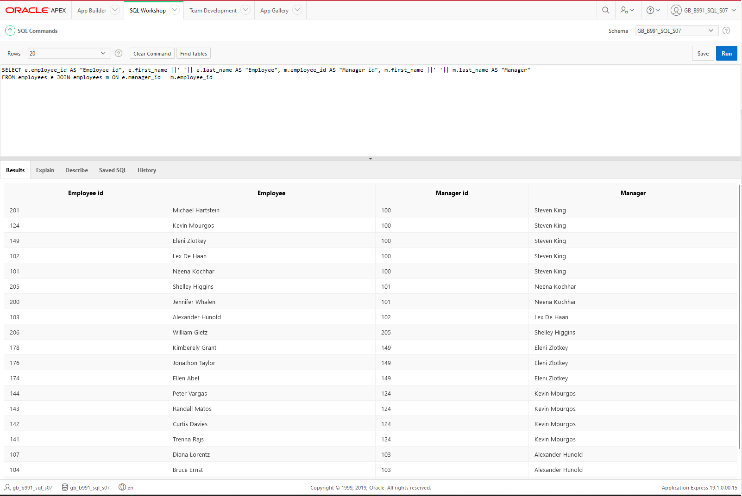

**Task 5**  
Display employee ID, last name, department ID, department name, and hire date for those employees whose hire date was June 7, 1994.

**Answer 5:**

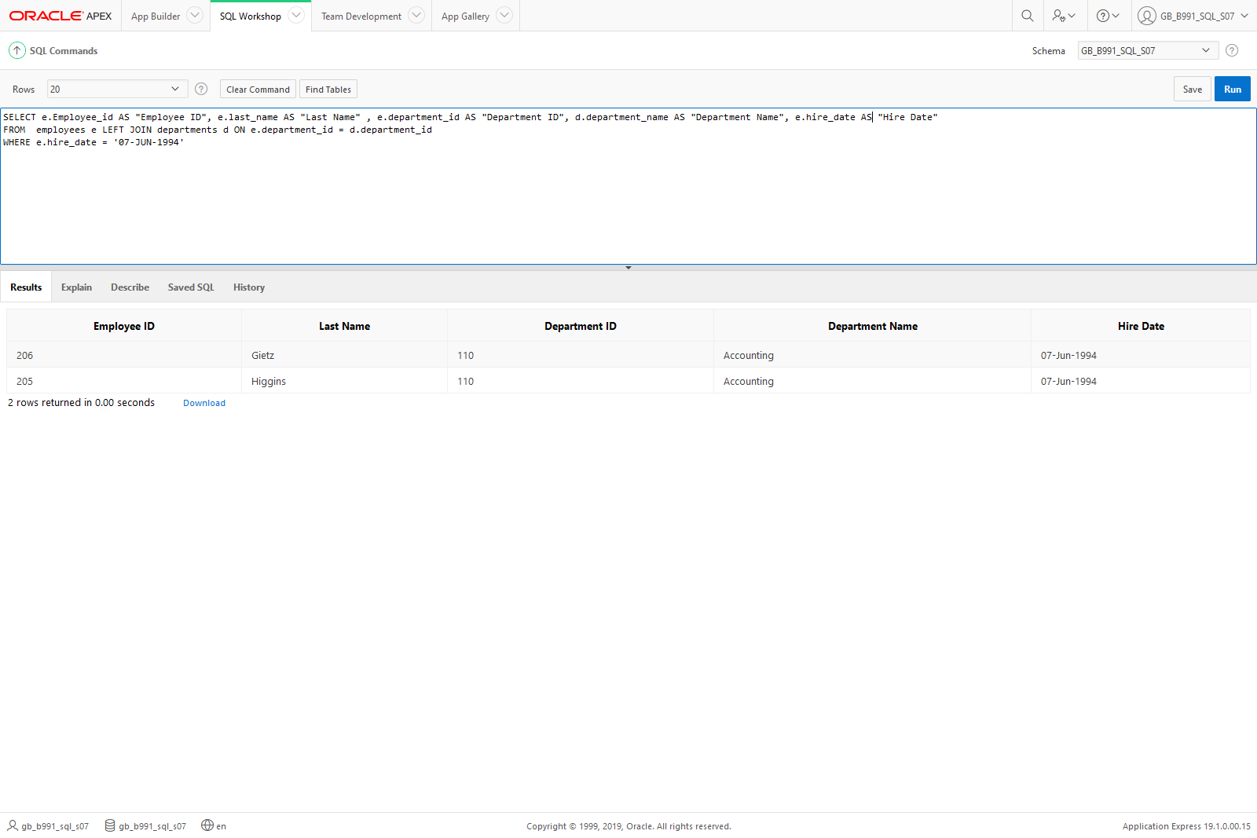

**Task 6**  
Return the first name, last name, and department name for all employees including those departments that do not have an employee assigned to them.

**Answer 6:**

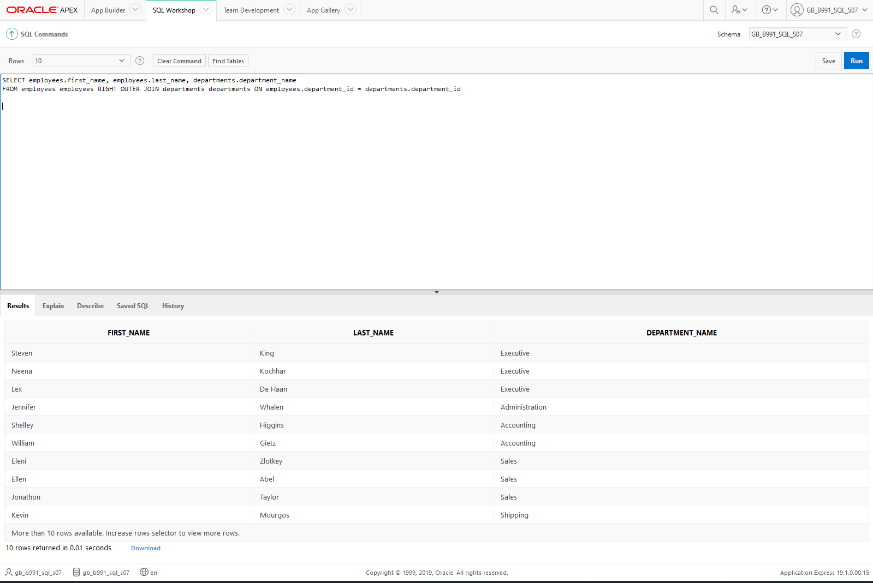

**Task 7**  
Create a query of the DJs on Demand database to return the first name, last name, event date, and description of the event the client held. Include all the clients even if they have not had an event scheduled.

**Answer 7:**

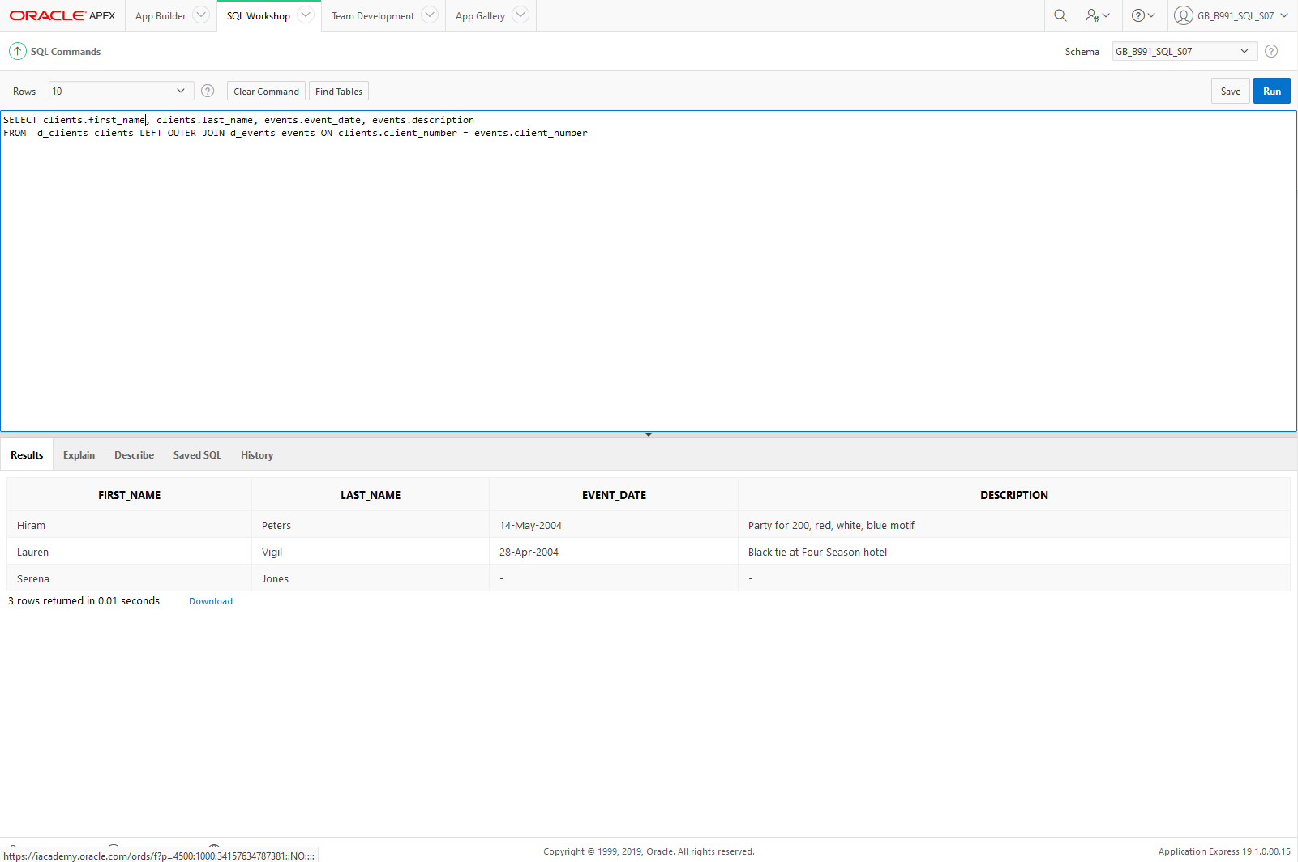

**Task 8**  
Using the Global Fast Foods database, show the shift description and shift assignment date even if there is no date assigned for each shift description.

**Answer 8:**

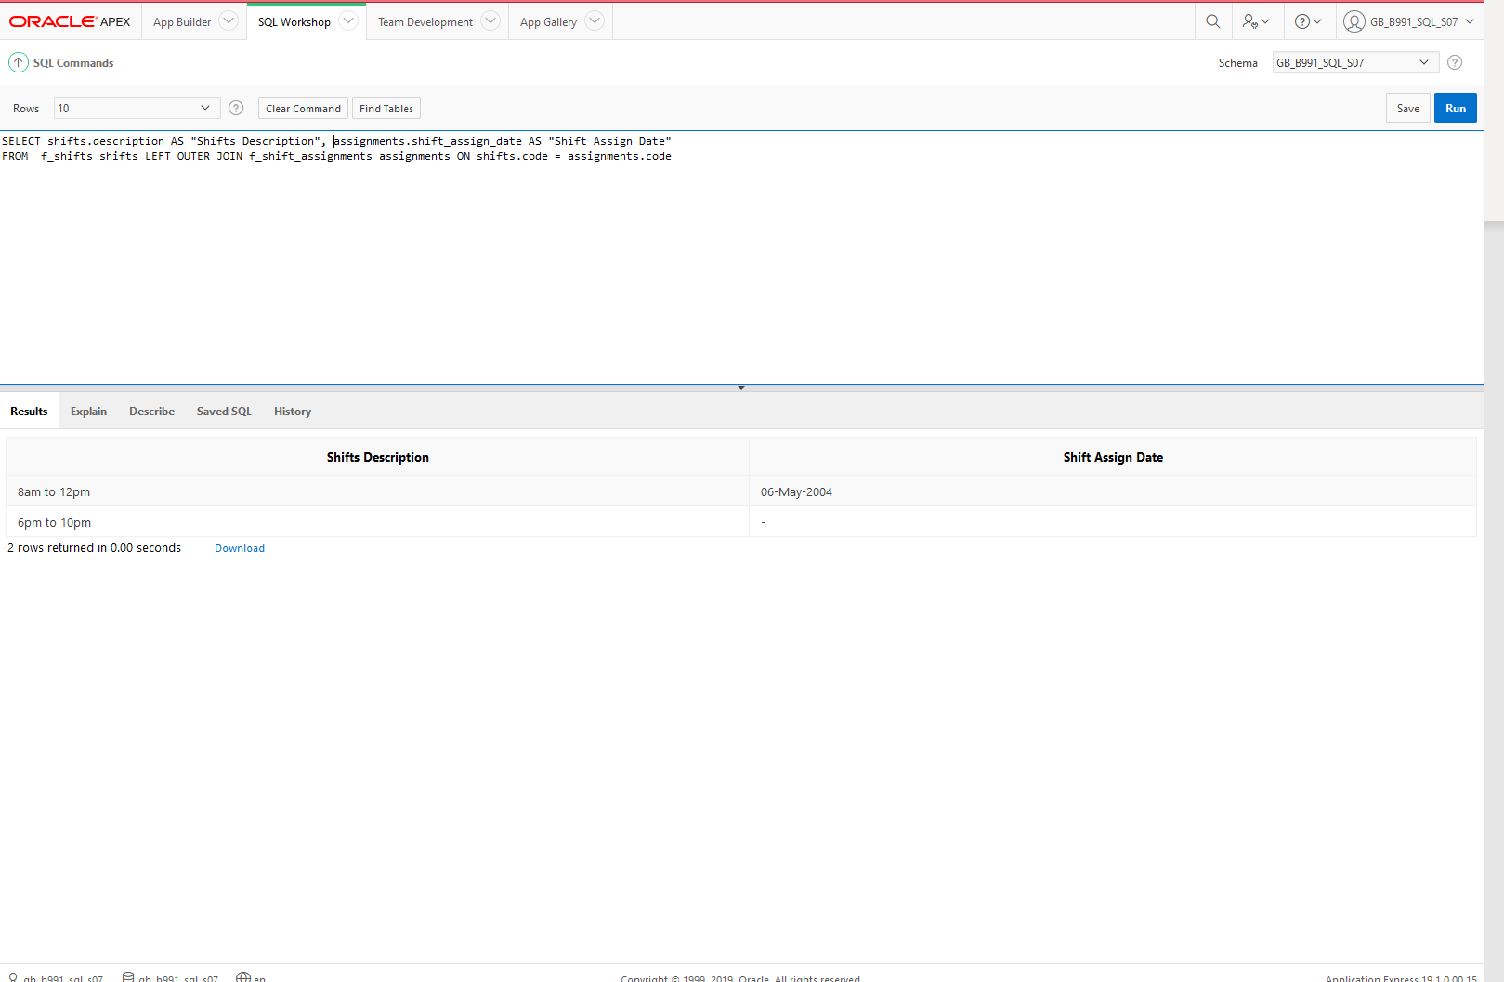

**Task 9**  
Write a query that will return both the maximum and minimum average salary grouped by department from the employees table.

**Answer 9:**

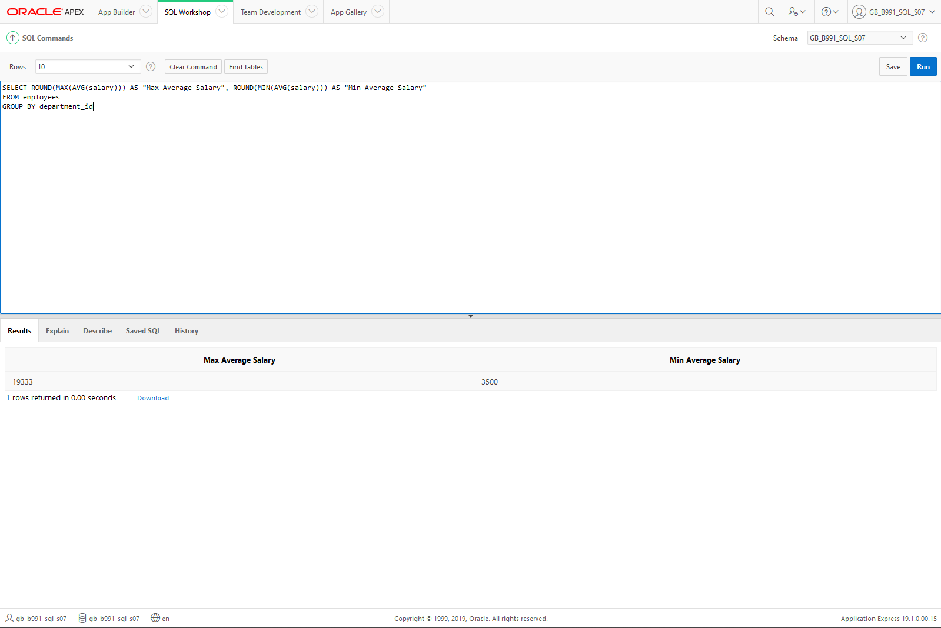

**Task 10**  
Display job title, employee first name, last name, and email for all employees who are not stock clerks.

**Answer 10:**

